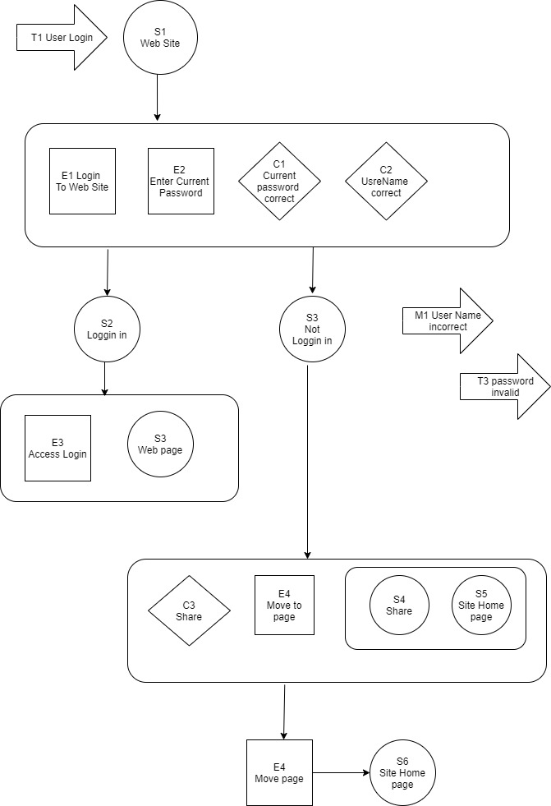

|  |  |  |  |  |  |  |
| --- | --- | --- | --- | --- | --- | --- |
| Event | Trigger | Message | Condition | Pre-state | Poste- state | Rule |
| E1/E2 | T1 | M1 | C1/C2 | S1 | S1 |  |
| E3 |  | M2 | C2 | S2/S3 | S2/S3 |  |
| E4 |  |  | C3 | S4/S5 | S4/S5 |  |
| E4 |  |  | C3 | S6 | S5 |  |
|  |  |  |  |  |  |  |
|  |  |  |  |  |  |  |